ContractNest (New Modules -Equipment registry, facilty, Resources, Contract combinations)
QA- Nilesh Deulkar
Release Date-17-Feb-2026

Cross is not working in Equipment registry form-
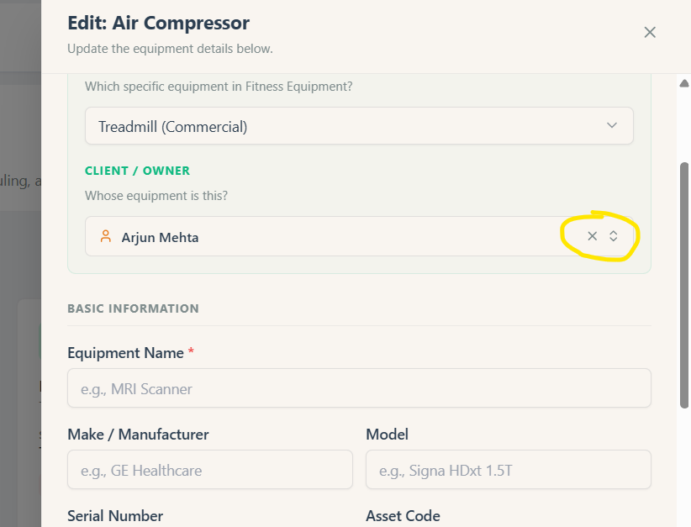

Facility Registry is displaying equipment form-
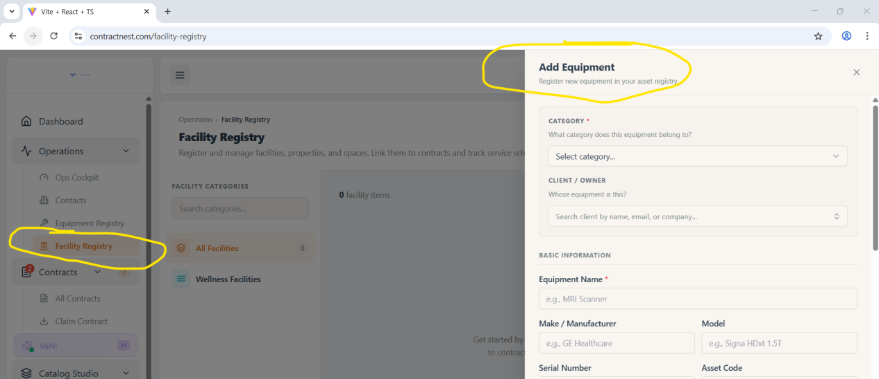

Add block image is not working-
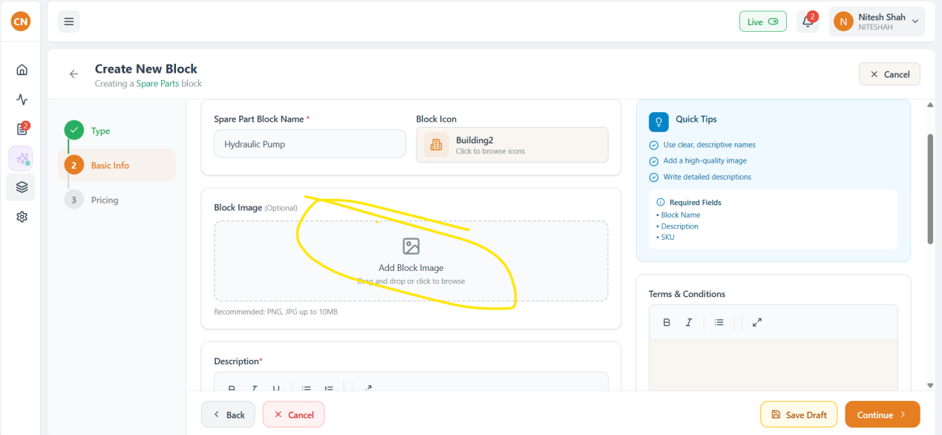

Unable to add Equipment while creating contract-
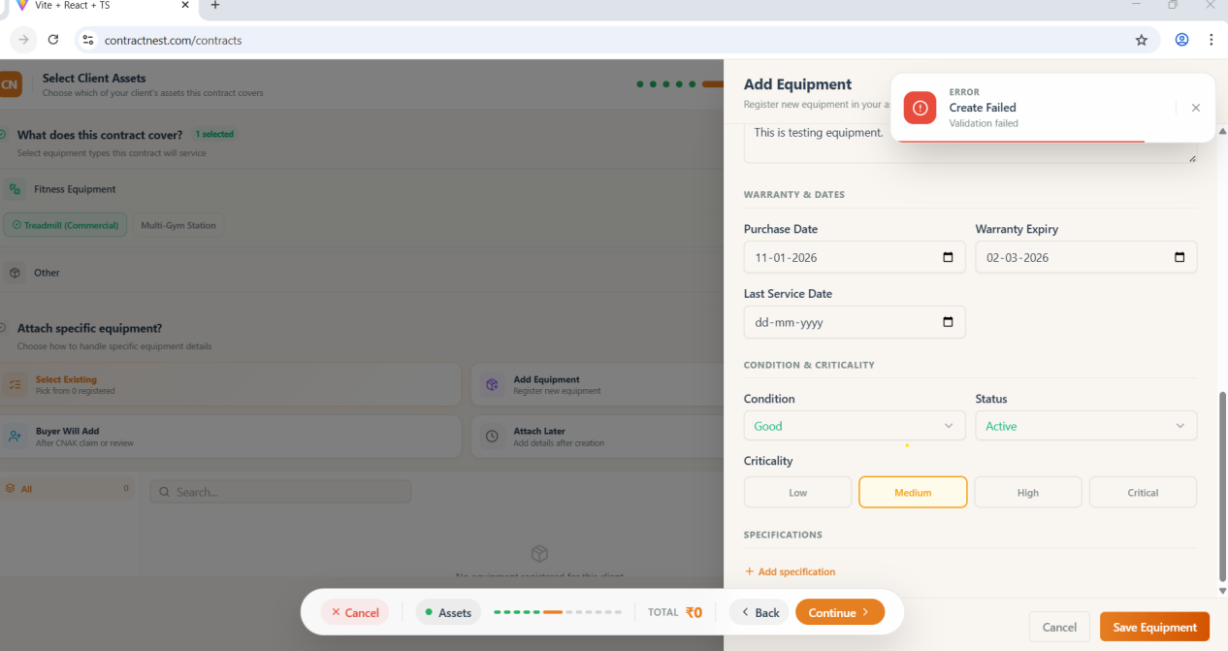

Existing Register Equipment are not showing while generating contract-
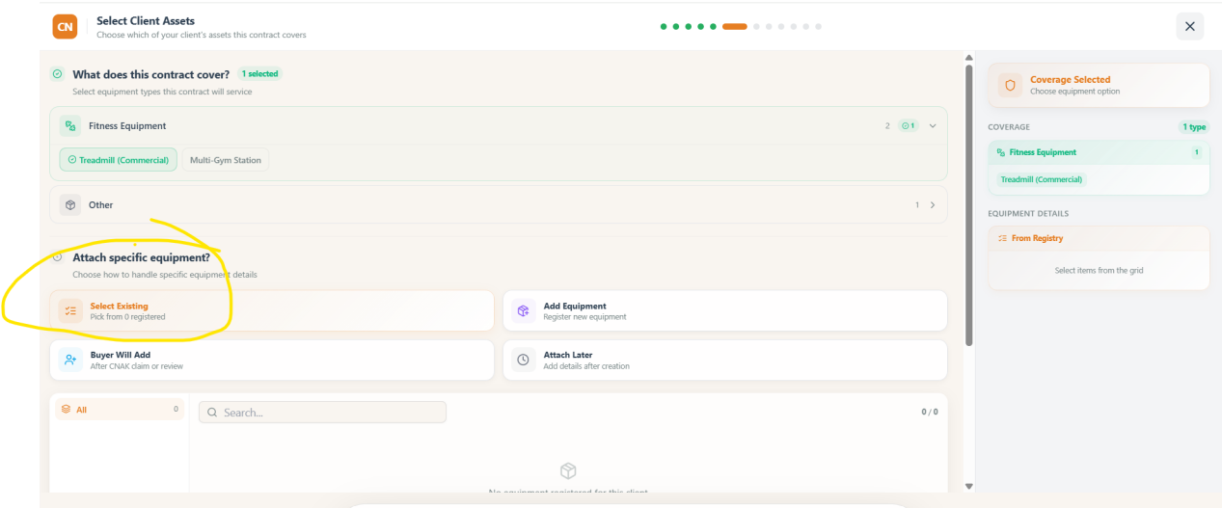

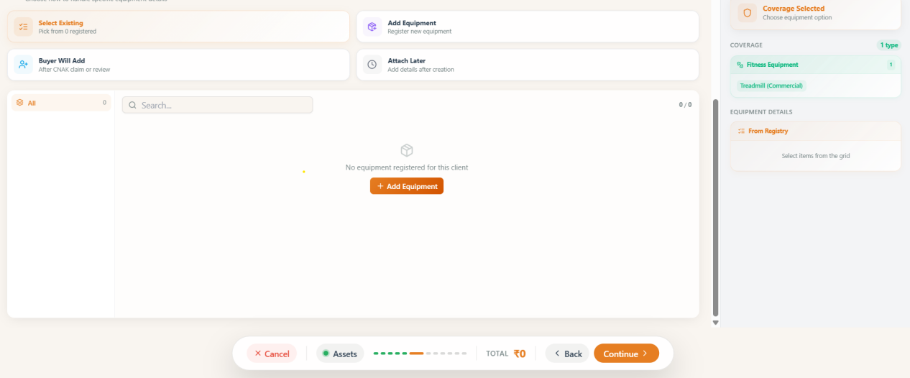

After sending contract Buyer is not able to accept via email link-
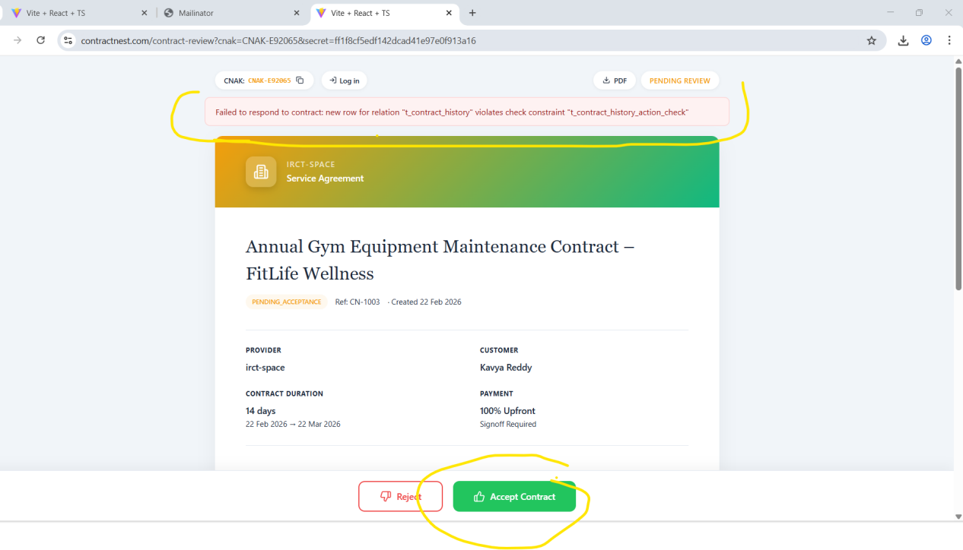

Contract Email not received on mailinator email-
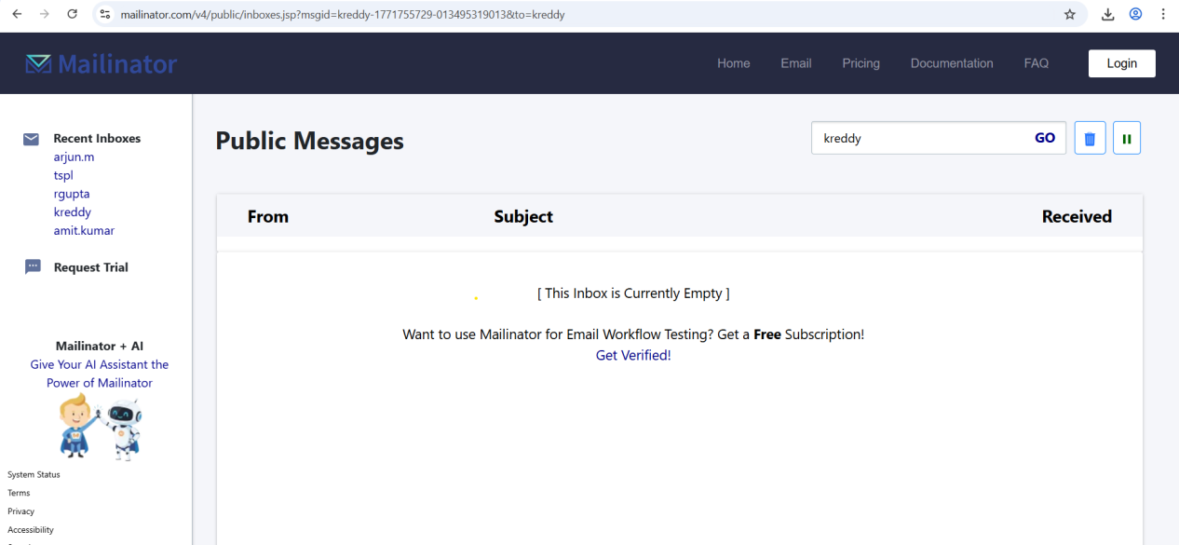

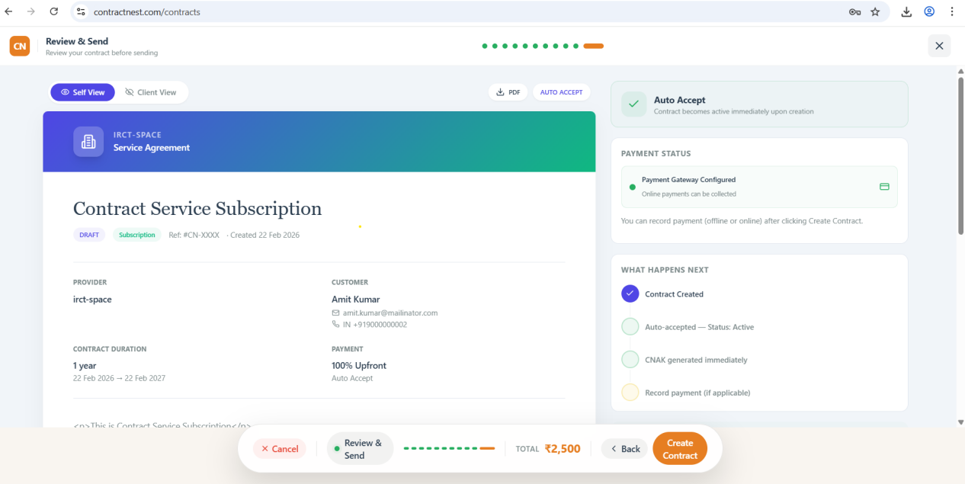

Resources SPa/sauna Unit is failed to add-
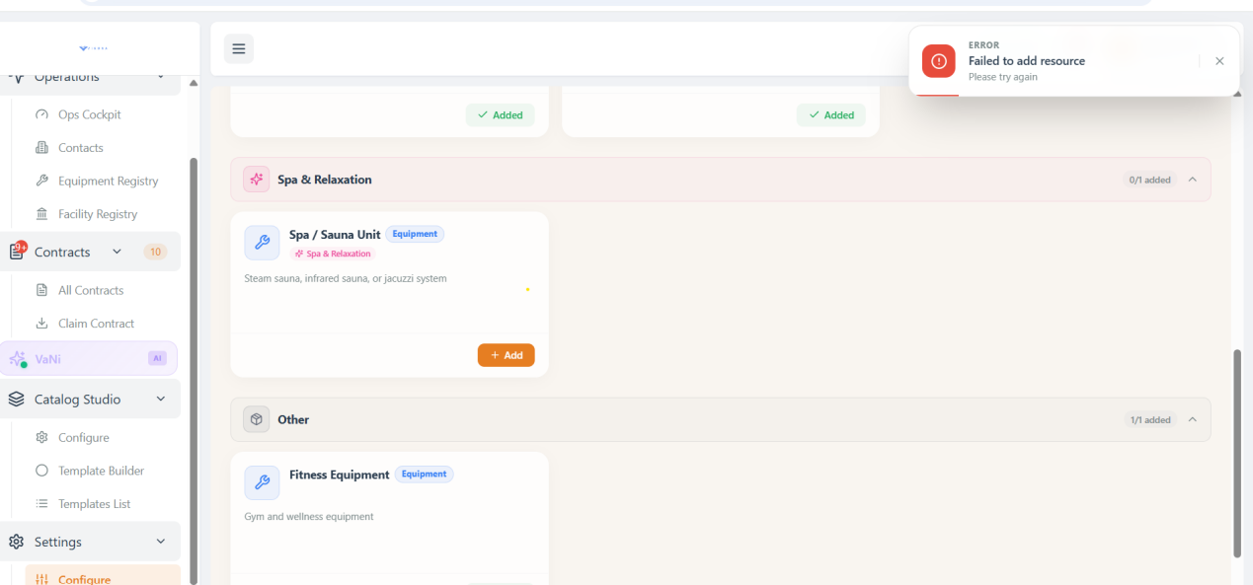

Manufacturing resource
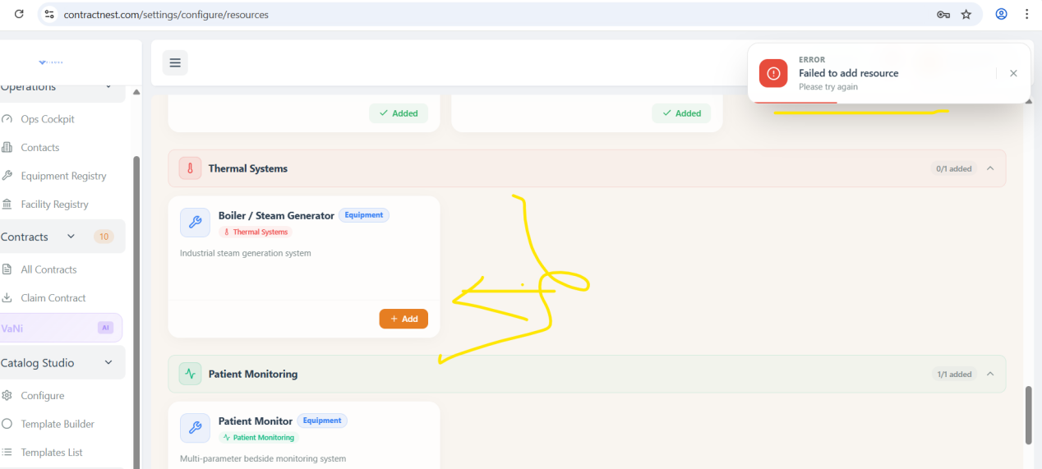

Added eqipment are not displayed while contract creation
Eqipment registered count is zero.

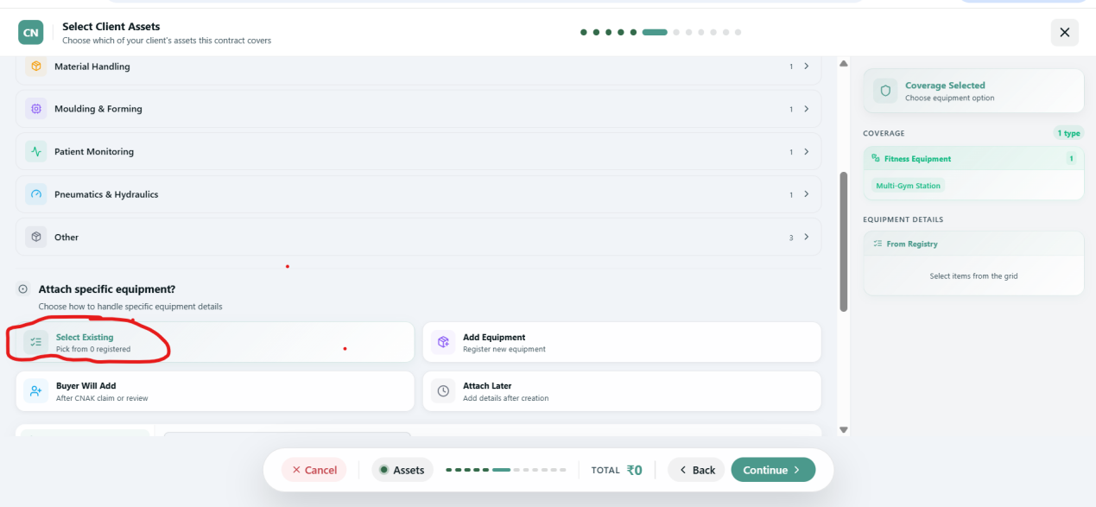

System is allowed create Unified contract with quarterly payment mode. Expecting to be select only prepaid.
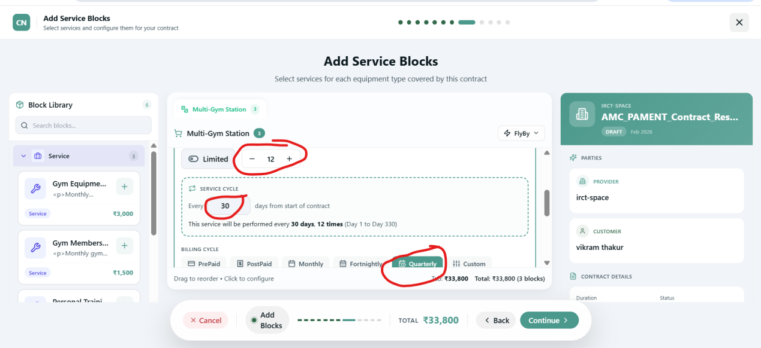

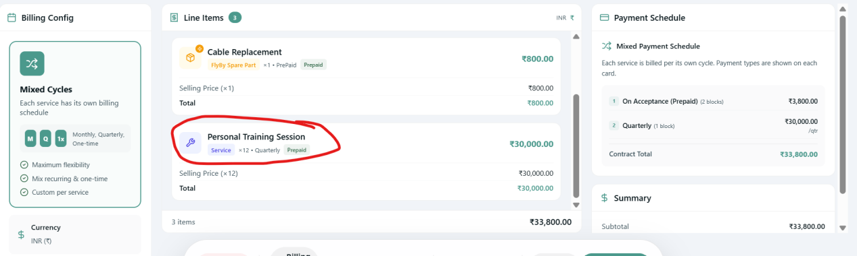

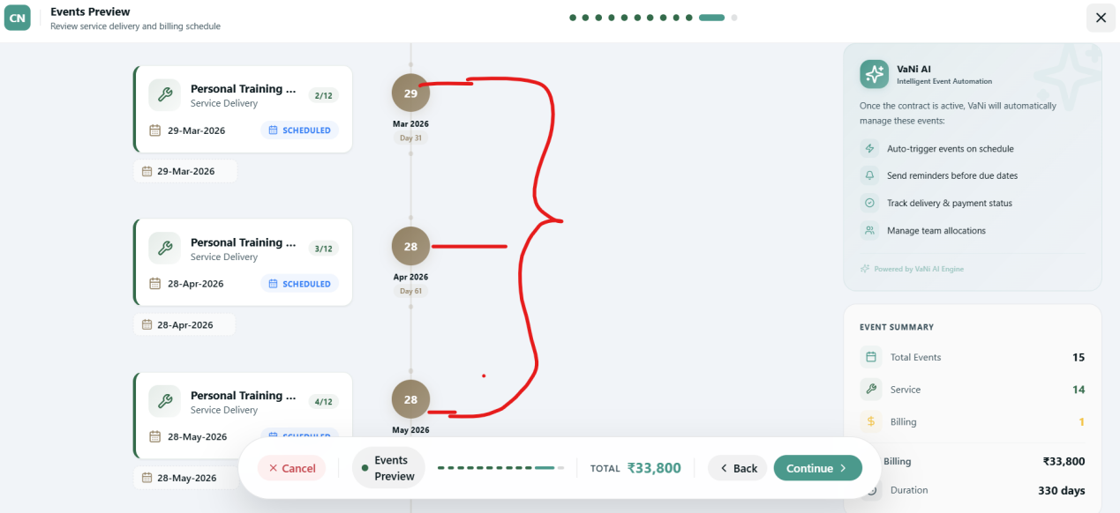

In Resource based pricing below block is showing before Euipment and Assets so need more info about it-
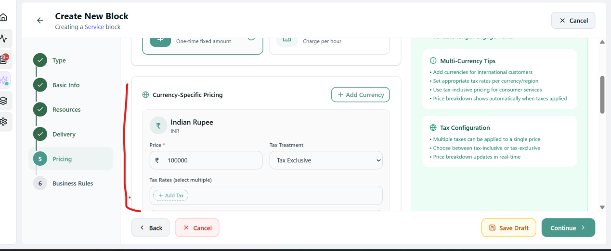

Individual and Resource dependent both are showing in Block Library but not displayed properly UI issue observed.
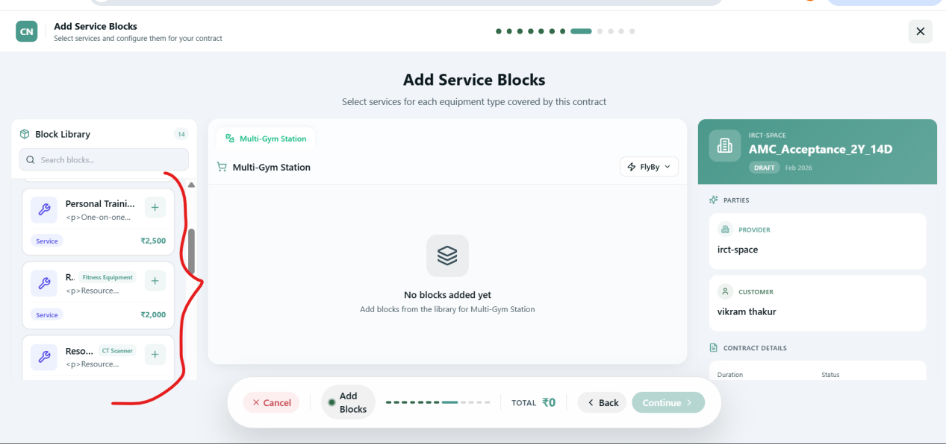

Contract send from application but not reflecting in Buyer email and JTBD admin.
Its flaky sometimes it worked and sometime wont..
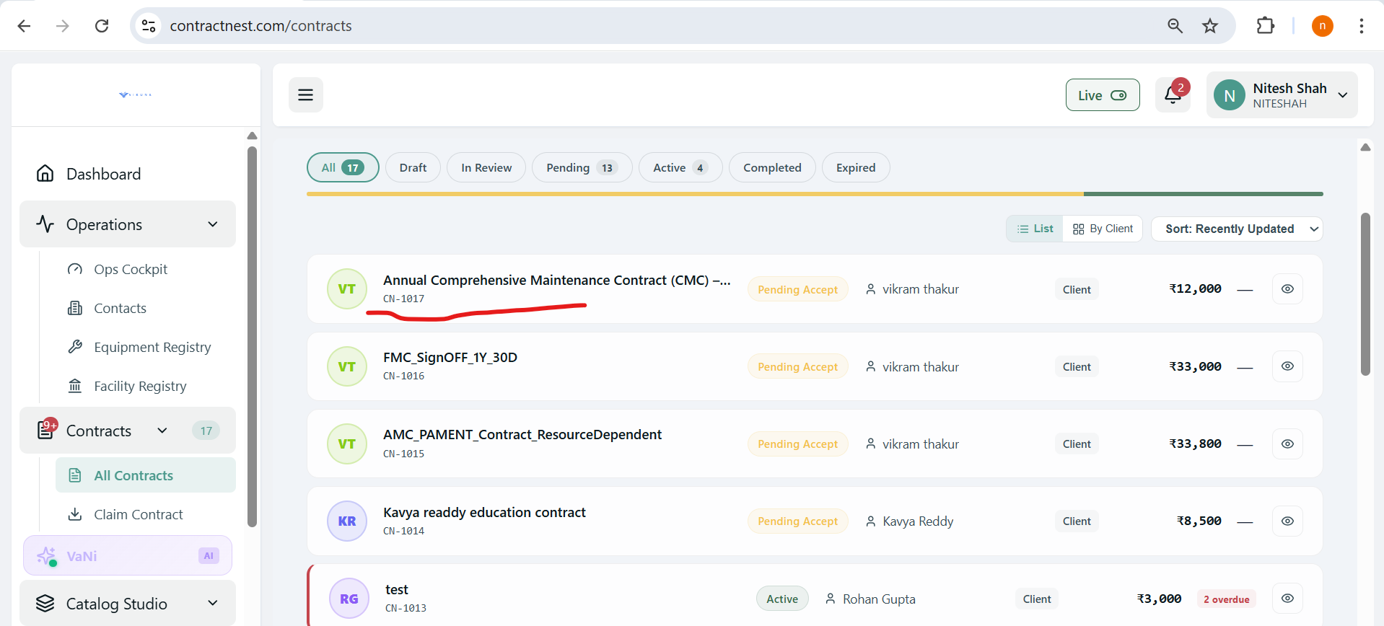
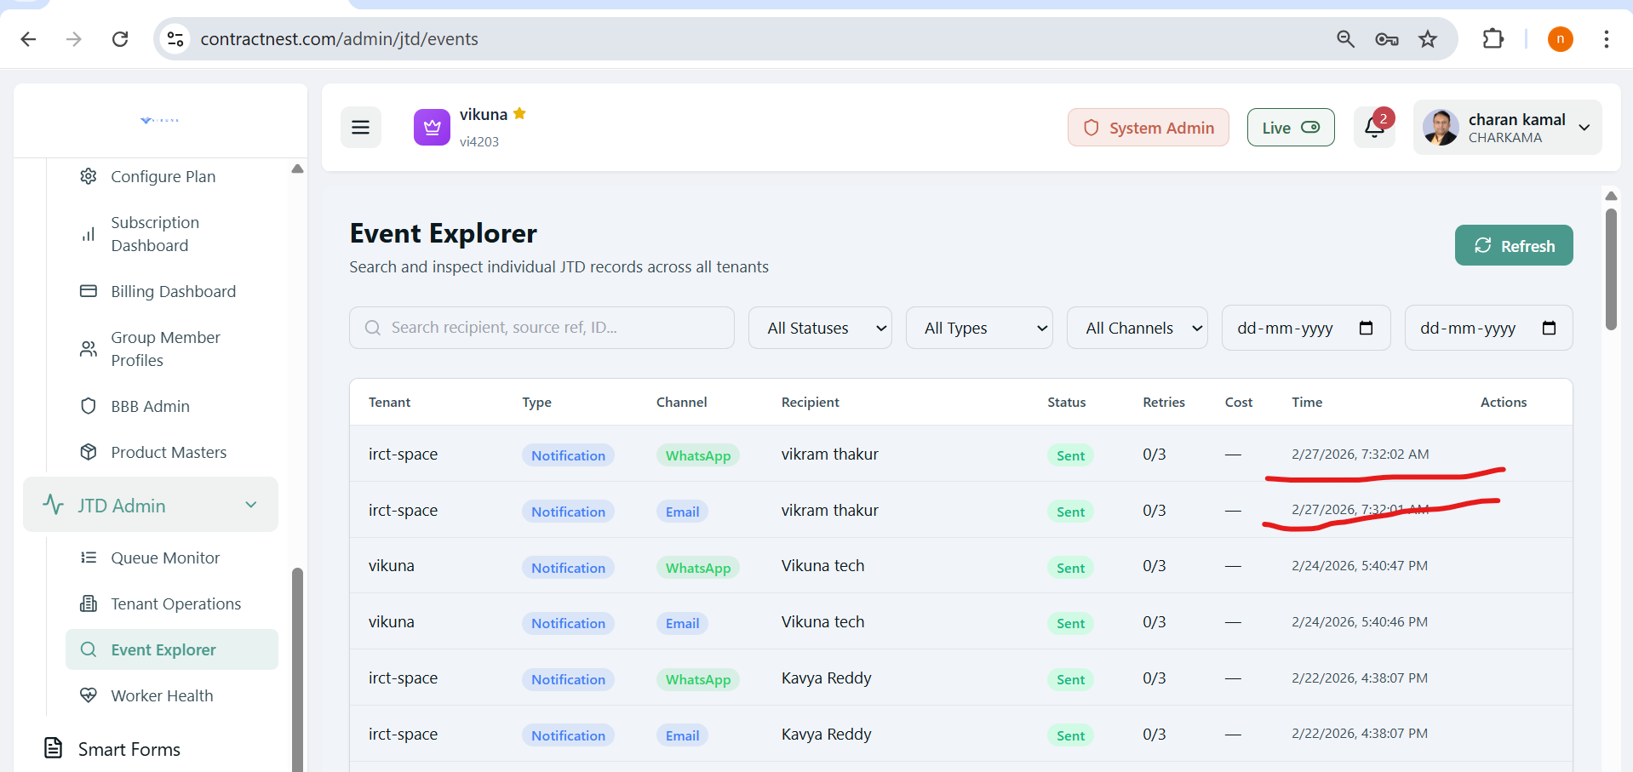

Generated Contract having UI issues-
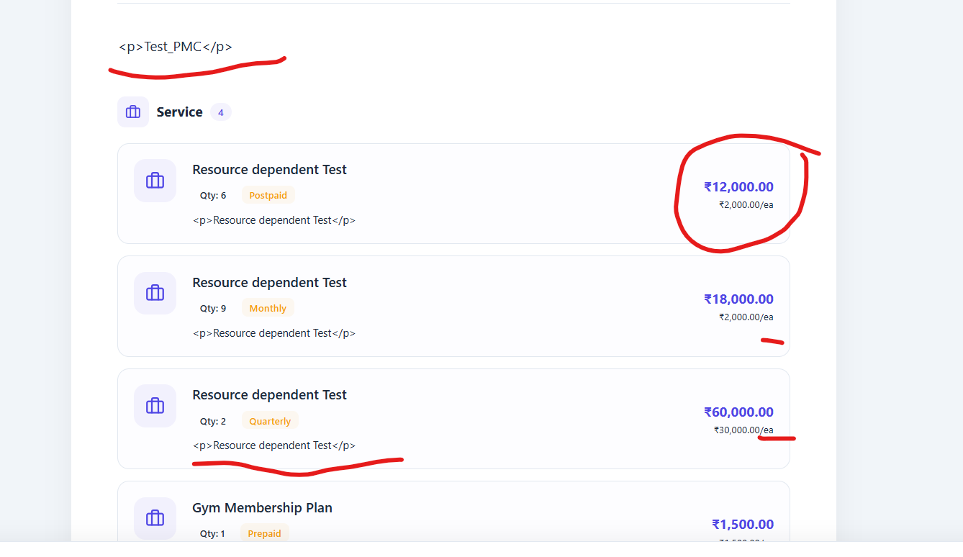
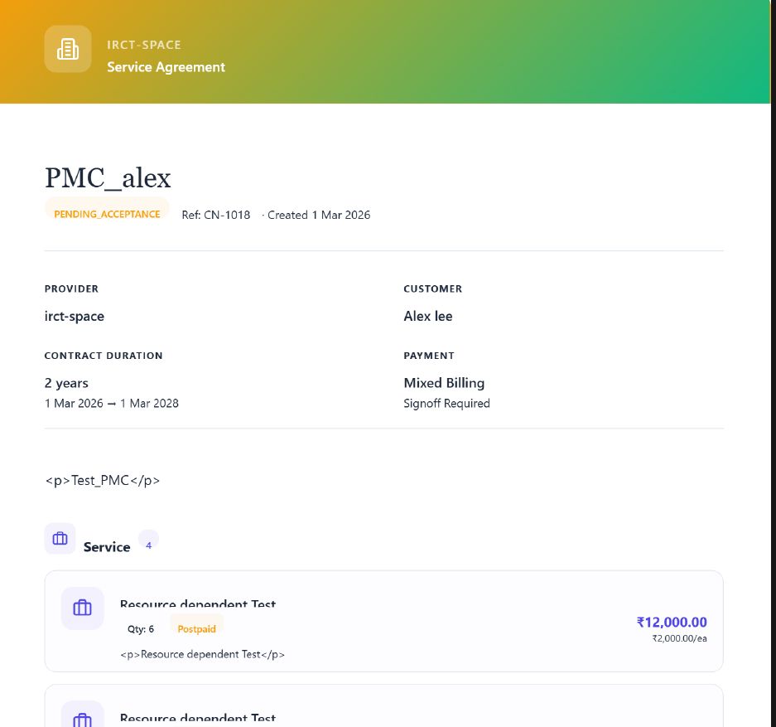

Contact creation is not working in in OpsCockpit..
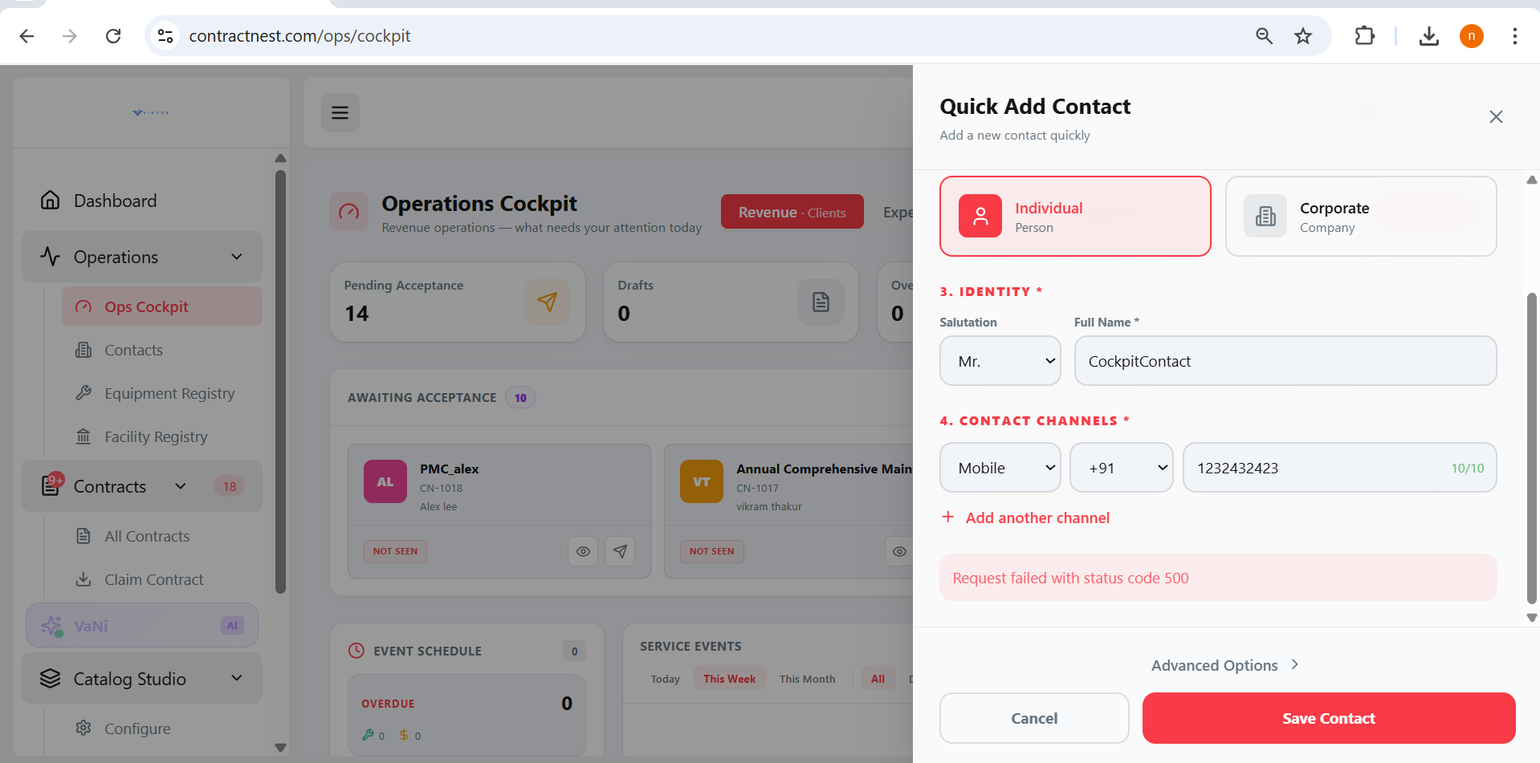

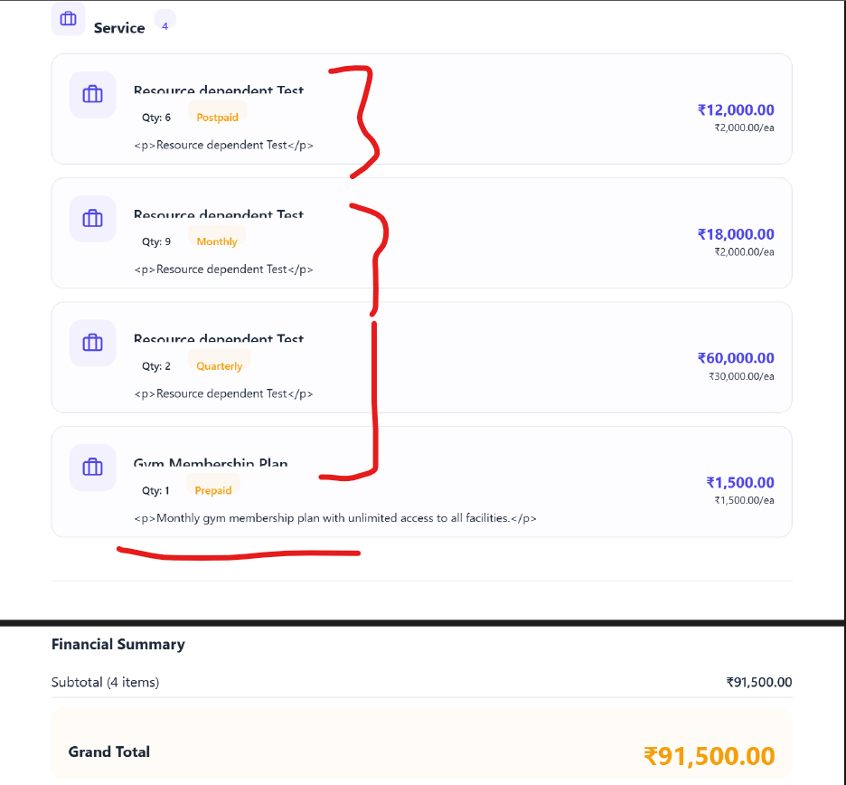

Contract Acceptance failed--
s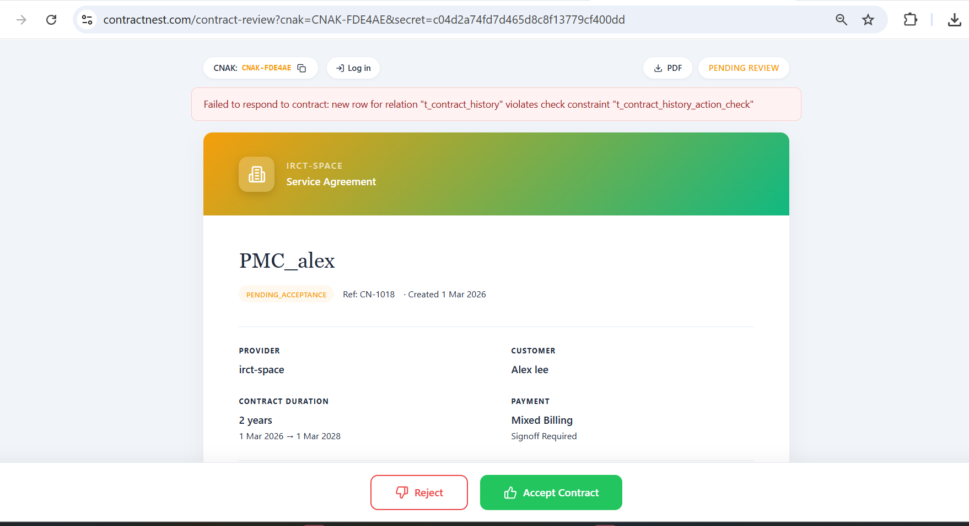

Unble to claim CNAK-
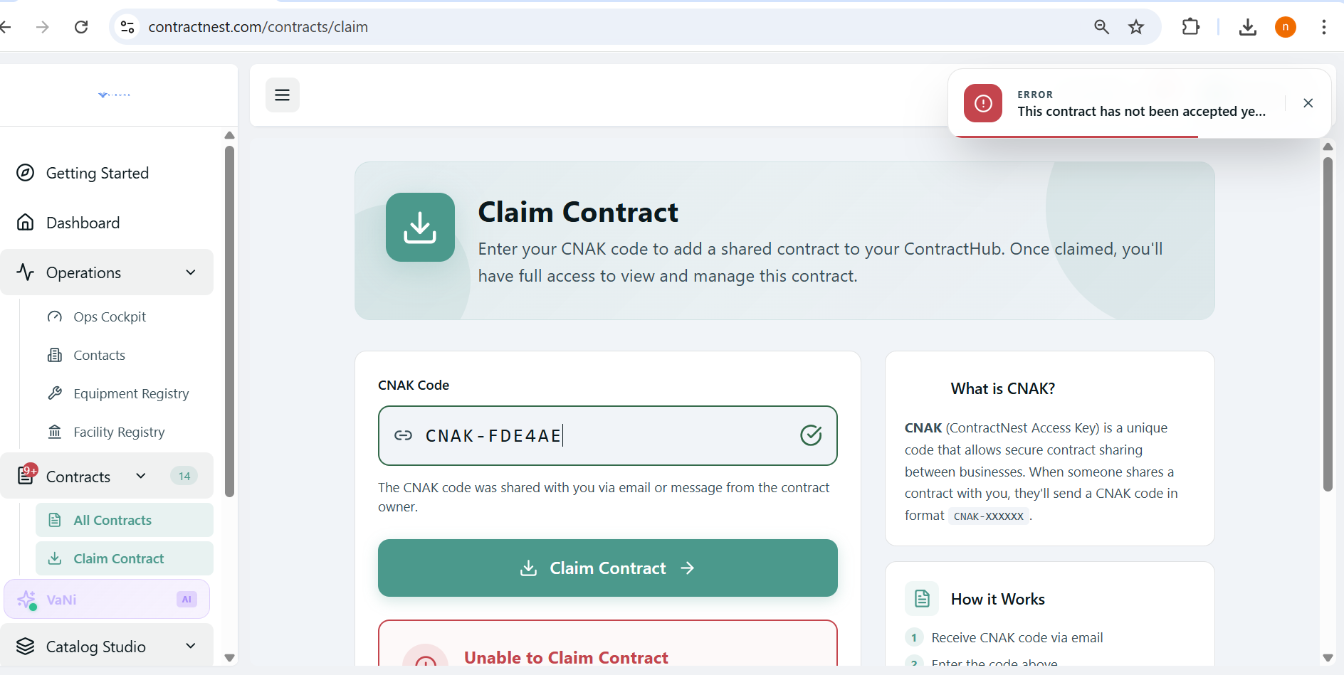

Unified cycle can accept quarterly billing but its taking upfron while collection-
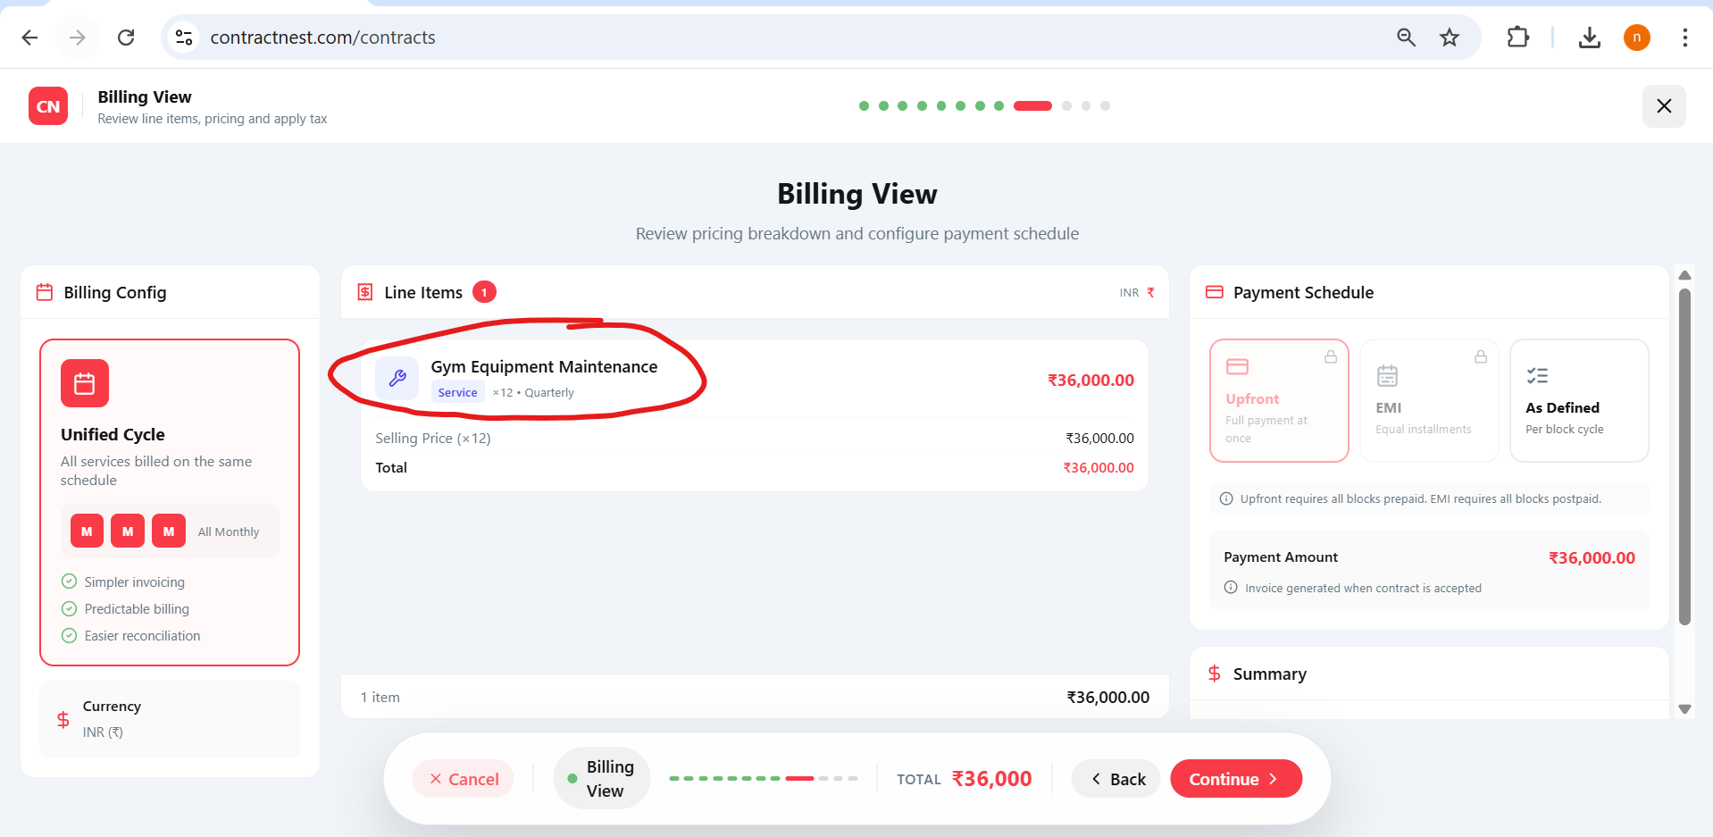

Auto Acceptance contract is not reflecting in buyer side.
